MISSION STATEMENT
OEA-Retired is dedicated to meeting the needs of its members, providing member involvement within OEA and supporting public education.

2018-2019 Officers
Bill Sears, Chairperson Mary Binegar, Vice Chairperson Peg Ham, Secretary
Carol Kinsey, OEA Director John Hoyes, Past Chairperson

OEA-R NEWSLINE is the official publication of OEA-Retired
OEA-R website: http://oea-r.ohea.us
Jack Boyd, Newsletter Editor/Webmaster

OEA FUND FOR CHILDREN AND PUBLIC EDUCATION
Help OEA-FCPE raise money to elect pro-senior, pro-union, pro-education candidates. It's quick and easy to donate electronically. Go to: http://ohea.org and click on the DONATE button at the top of the page.

STRS REPORT

The STRS Ohio Board of Directors’ hired the Korn Ferry Firm to help us search for a replacement for Mr. Nehf when he retires June 2020. The firm is headquartered in Atalanta, GA. Now that a firm has been selected the preliminary search work will begin in late summer and early fall. I will keep you apprised of the progress of the search.

The Board approved the Investment Plan for 2020. John Morrow and the Investment Managers reviewed their individual plans for each investment portfolio. The Investment consultants from both Callan and Cliffwater were both in attendance to explain why they thought this was a very good proposal for the fund. Both the outside consultants reminded the Board that STRS Ohio is fortunate to have such an outstanding investment team in house. Many other public pensions are envious of how much internal investing we have the capacity to do because it saves the fund a tremendous amount of money.

John Morrow reported that the total fund return was -2.6% in May. For fiscal 2019 year to date the return is +3.3% which is below our expected rate of return of 7.45% We have the remainder of June to see how that ends up. Investment asset as of May 31, was an estimated $76.3 billion.

Retirements for 2019 are up from last year. STRS Ohio has received 3,018 applications for retirement as compared to 2,335 applications last year. Members continue to prefer the online application as four out of five members apply online.

Paul Snyder reviewed the proposed budget for 2020. Each annual budget is a means to accomplish the STRS Ohio mission, vision and strategic goals. The proposed budget is 2.66% ($2.66 million) higher than in the fiscal 2019 budget. Remember that STRS Ohio saves $95 million annually by the staff managing about 71% of our assets. We have reduced the number of full time equivalent associates in the budget from 585 in 2014 to 535 in 2020. We are functioning below budget for 2019. The budget was approved.

Gary Russell reviewed the Proposed Changes in the Health Care Program for 2020.
The following changes were recommended and adopted for the Medical Plan

Changes for the Medical Mutual Basic Plan for non-Medicare enrollees
*Add a 24-hour nurse line
*Require transplants to be performed at Organ Transplant Centers of Excellence (no out-of-network coverage)
*Staff recommends moving AultCare Medicare Parts A and B enrollees to the AultCare Prime time Health Plan HMO Medicare Advantage Plan (approximately 900 enrollees)
*Current AultCare PPO 30 year premium is $258 compared to $127 for Aetna Medicare Advantage
*AultCare Prime Time Health Plan HMO 30 year premium for 2020 will be $154
*Enrollees with Medicare Parts A and B will be automatically moved
*Member Education will provide open enrollment meetings next fall in the AultCare service area
*Increase drug maximum out-of-pocket limit to $6,350 from $5,100 for the Medicare plans to align with 2020 standard Medicare prescription plan
*Change the specialty drug coinsurance from the lesser of 13% or $550 per fill to the lesser of 13% or $450 per 31-day period
*Add Saveon SP manufacturer copay assistance program for non-Medicare enrollees

92% of enrollees will have no premium increase in 2020
83% will have a premium decrease
9% will have the same premium in 2020 as 2019

8% of enrollees will have a premium increase in 2020
4% will have an increase between $1 and $9 per month
4% will have an increase of $10 or more per month

Premiums for Aetna Medicare Advantage, the largest plan representing nearly 80% of enrollees, have not increased since Jan. 1, 2016

Medicare Part B Partial Premium Reimbursement

*Benefit recipients currently enrolled in the Health Care Program and Medicare Part B receive $29.90 per month to reimburse a portion of the Medicare Part B premium
*Approximately 85,000 benefit recipients receive reimbursement at an annual cost of about $31 million
*Previous board action reduces reimbursement to $0 beginning Jan 1, 2020
*Extending $29.90 per month reimbursement for one year will cost about $31 million or 0.84% of Health Care Fund assets.
*Adopting a permanent $29.90 Medicare Part B premium reimbursement will increase the plan liability by about $350 million, reducing the projected July 1, 2019, funded ratio to 155% from 181%
-That includes benefit recipients currently receiving the reimbursement and future benefit recipients as they age into Medicare
*Another option is to continue the $29.90 reimbursement for the lifetime of only those enrollees currently receiving a reimbursement
-Increases program liability by about $250 million rather than $350 million
-Reduces the July 1, 2019, projected funded ratio to 162% from 181%

The Board decided to continue the $29.90 monthly reimbursement for one year through Dec. 1, 2020 and evaluate permanent reimbursement in conjunction with providing a level of inflation protection for pre-Medicare subsidies

Article by Rita Walters, STRS Board Member
Ed Note: STRS did not meet in July.

UNIT REPORTS

Capital
Our annual meeting was held on June 19, 2019. The results from the election committee are as follows: Judy Valentine, President, Jeff Corbin, Vice-President, and Sherry Grimes, Secretary. The members of the executive board are, Carrie Boston, Marge Dorman, Deb Downey, Gigi Morelli, Joanne Rudisill, Beth Shelley, Allen Suggs and Karen Zellner.

Our upcoming events include: A tour of Al's Delicious Popcorn and lunch at Morone's Italian Villa on September 12th, and a lunch at Schmidt's Restaurant and Sausage Haus on September 23rd, with Speaker David Cohen. He will speak about his latest book, 1000 Years of Memories. The book relates the remarkable stories of ten individuals who have reached the age of 100 and beyond.

On October 8th, we will travel to Greenville, Ohio to tour all things related to Annie Oakley, and have lunch at the Montage Café. On October 30th, we will meet for lunch at Valter's at the Columbus Maennerchor. After lunch we will board a bus for a "spooky" tour of Columbus with host Anietra Hamper, a former local newscaster.

Our annual silent auction will be held once again at Berwick Party House on November 7th, so pack up those unwanted items and put them in the auction. The buffet lunch always includes those delicious fried mushrooms that the Berwick is known for. Our group will travel to Canton on November 16th, for a performance at the Canton Palace Theatre, and lunch at La Pizzaria.

We have outstanding trips planned for the month of December. We will celebrate the holiday season with a tour of New Orleans, which will occur December 1-4. Our activities for 2019 will conclude on December 6th with a trip to La Comedia in Springboro for a performance of Elf The Musical.

Article by Jeff Corbin

East Central
ECOEA-R members and guests will hold their annual “Not Back to School Lunch” on Wednesday, August 21. It will be at Mulligan’s Restaurant, 4118 Belden Village St NW, Canton. We will meet at 11:30 and each person will order their lunch from the menu and self pay. We are privileged to have STRS Board Trustee Rita Walters (also an OEA-R member) attend to provide a firsthand STRS update. Due to ongoing changes at Mulligan’s, reservations are REQUIRED. Please RSVP to Carol Kinsey, Cskinsey@aol.com or 330-495-2318, no later than August 16. There will be discussion about other possible ECOEA-R events for the upcoming year so bring some great ideas with you! Also SAVE THE DATE for the always popular annual Holiday Happenin’ Lunch at the awesome Pine Tree Barn “out in the country”. That will be Tuesday, December 3 at 11:30. Again attendees will order their favorite items from the menu and self pay. More information will be forthcoming closer to the date and reservations will be required and accepted on a first come basis. Each event offers time for reconnecting and reminiscing as well as meeting others for the first time. Sometimes there are prizes and surprises! Don’t miss out! We welcome OEA-R members from other Districts to enjoy our events with us——just please be sure to make a reservation.

Article by Carol Kinsey

Eastern
Eastern OEA-R continues to have lunch in Zanesville each month at the Olde Falls Inn. Our numbers seem to be diminishing perhaps that is due to the summer travel season or lack of interest. Hopefully the numbers will improve with encouragement. We shall see. The Eastern Board of Directors will not meet until September to make plans for next year. We will keep you updated.

Article by Rita Walters

North Central
Luncheon was held June 3rd, 2019 at " The Old Bag of Nails " in Mansfield, Ohio. We were glad to welcome guest David Tovey. Those in attendance were Becky Mayer, Perry Brokaw, Joyce Skocic, Chris Swank, Donna Potter, Paul Lewis, Peggy Spillman, Judy Novak and Carol Kinsey.

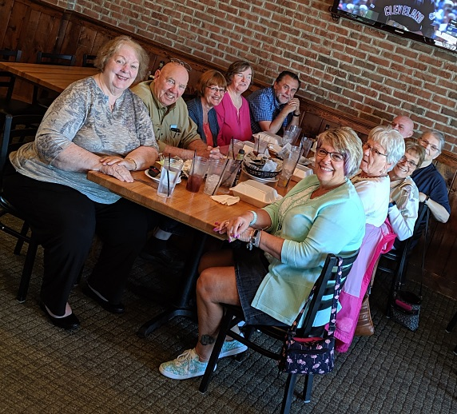

Becky Mayer and Judy Novak were involved in our grant. We used the Hustle phone application to contact and encourage members to attend summer training opportunities offered by OEA. It was enjoyable to have contact with active members.

We are looking for someone to be our web master. Our members would be able to access pertinent information concerning Education issues. Information concerning our future meetings and social events would also be listed. You would be able to access the website through OEA's website.

Future meetings include:

"Not Back to School " Brunch on August 14th at 11:00
Location: IHOP Restaurant, Lex-Springmill Rd., Ontario

"Holiday Luncheon and Ornament Exchange" on December 9th
Location: To Be Announced

Article by Judy Novak

Southwestern
SWOEA-R Executive Committee met on June 6th to look at the calendar for next year to coordinate with the district and look at ways to increase membership and participation. Our General Meeting was held on May 14th at the SWOEA office, with the program focusing on Social Justice.

SWOEA-R members also participated this past year in the OEA New Educator program through an OEA-R grant to help facilitate with OEA actives in reaching out to Early Educators and New Educators to the profession. Along with the goal for reaching out to this group, we also contacted local leaders to help with updating membership list following the Janis decision.

Bill Sears, Judy Buschle and Deloris Rome Hudson represented SWOEA-R at the 2019 National Education Association-Retired Organizing Conference held in Denver, CO. on March 17-128, 2019. The focus was Leading and Learning for retirees. The featured guest speaker was former NEA Executive Director, John Wilson.

SWOEA-R, Deloris Rome Hudson and Judy Buschle were elected to attend the NEA-R retiree meeting and NEA Representative Assembly held in Houston, Texas.

At the June 6, 2019, the SWOEA-R Executive Committee meeting dates were set for the upcoming year along with scheduled activities for the 2019-2020 year for member participation. In the SWOEA-R summer newsletter the dates and locations will be listed.

Article by Judy Buschle

Western
WOEA-R approved support for Sophia Rodriguez for OEA vice president. While the outcome is not as we hoped, WOEA-R thanks Sophia for consistent and constant support of retirees in WOEA and OEA. We know she will continue to advocate for retired members in her continuing capacity with WOEA, OEA, and NEA!!! WOEA-R is proud of you, Sophia!!!!

Marge Punter encourages members to bring items for Artemis for each meeting. School, personal items and gift cards are needed. Book bags will be needed in September.

FCPE contributions since September 2018 were $1063. We appreciate the contributions from 21 individuals.

Elected for NEA-R delegates from WOEA-R: Willie Terrill and Phil A. Long. Jane Rahn, alternate.

Elections were held for WOEA-R officers at the June meeting. Chair: Phil A. Long; Vice Chair: March/April – Marge Punter; May/June – Bonnie Bozovich; Secretary: Lori Moodie; Treasurer: Sandy Dobberstein. Wayne Wlodarski will be the newsletter editor. Several others will continue.

Jennie Furnas was thanked for 6 years as secretary and Sandy Dobberstein 3 years as vice chair.

Tara Koenig will represent WOEA-R on the OEA-R Rapid Reaction Team.

WOEA-R members Sandy Dobberstein, Jane Rahn, and Phil A. Long are attending Uniserv Council meetings in WOEA. Assignments are: Sandy Dobberstein: Far West, Western, Miami A&B; Jane Rahn: Greene County and Happy Trails; Phil A. Long: Grand Lake and Grand Old River. The response has been very positive. The cooperation and support of the LRCs is greatly appreciated. OEA-R is working on an NEA grant/project to reach Early Career Educators. WOEA-R has been reaching out to young educators.

WOEA-R donated $50 to the DEA Scholarship Fund as appreciation for using the DEA office for mailings.

Join at any time during your employment the OEA/NEA-Retired. The OEA-Retired Advisory Council, which is 10 retired members from the 10 districts and officers, voted to have a promotion for any classified member (ESP) of OEA/NEA. A drawing will be held. The new member has a 10% chance of being reimbursed when joining OEA/NEA Retired as a unified member between now and August 1, 2019. There will be a drawing for every 10 members that join. So join now. You and your membership are priceless!

Join Online: www.nea.org/JoinNea or join by contacting your local leader and asking for a pre-retirement form, or contact Membership at OEA 225 E. Broad Street, Box 2250 Columbus, OH 43216 and request a paper form for Pre-Retired OEA-R/NEA-R. Then fill out form and mail in with your check.

Keep all WOEA-R members in your thoughts.

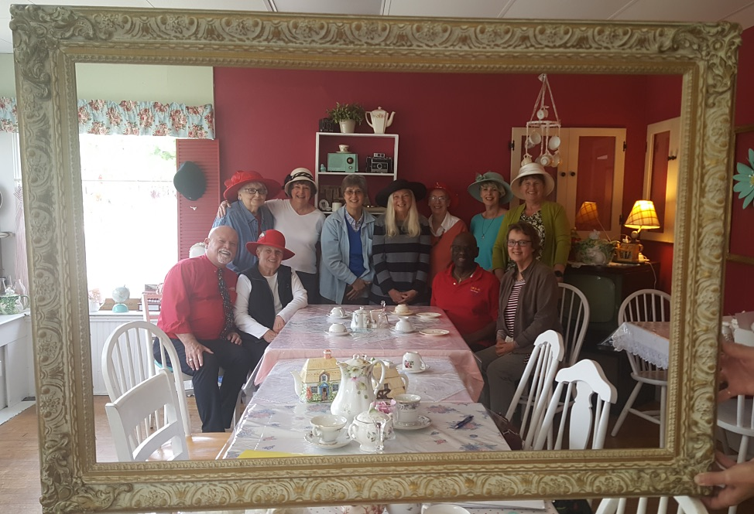

Article by Phil Long

Grant Committee Report
The 2018-2019 grant titled “Leadership Development for Organizing Through the New Educator Program” and the members of the committee are Judy Buschle, Chair, Mary Binegar and Carol Kinsey with input from Past Chair, John Hoyes and Todd Jaecks, Staff Liaison. The NEA-R awarded $5,142.52 to OEA-R for implementation. Our main focus for the grant was to work with Ohio’s O.N.E (Ohio New Educator) Member Ambassadors to strengthen our relationship with the state affiliate and local leaders. Working with Uniserv Councils, Staff Liaisons, and O.N.E. Member Ambassadors helped to provide an opportunity for retirees to support our actives in engaging new aspiring educators to join the local, fill out New Educator forms and attend O.N.E. events and activities.

The committee and volunteers from the districts worked in Phases to accomplish our goals. Phase I consisted of contacting Early Educators through an APP titled “Hustle” that allowed us to reach out through text messaging our Early Educators and welcoming them to OEA and the profession. Then in Phase II participants followed up with local leaders to assist in updating the state OEA membership list through emails/phone calls/ and meetings. Phase III the committee again used “Hustle” to contact our Early Educator’s about upcoming trainings available to them this summer. The final Phase, IV was completed with the members of the committee meeting with participants and reviewing the outcomes of all four Phases. Following this meeting the final evaluation was then compiled by the Grant Committee and submitted to NEA-R. Along with the completion of the evaluation the committee then looked at areas to be improved upon, as well as what could be included for the next grant to help OEA-R become more visible and valuable to the OEA organization in promoting and supporting public education professionals.

Article by Judy Buschle, Grant Committee Chair

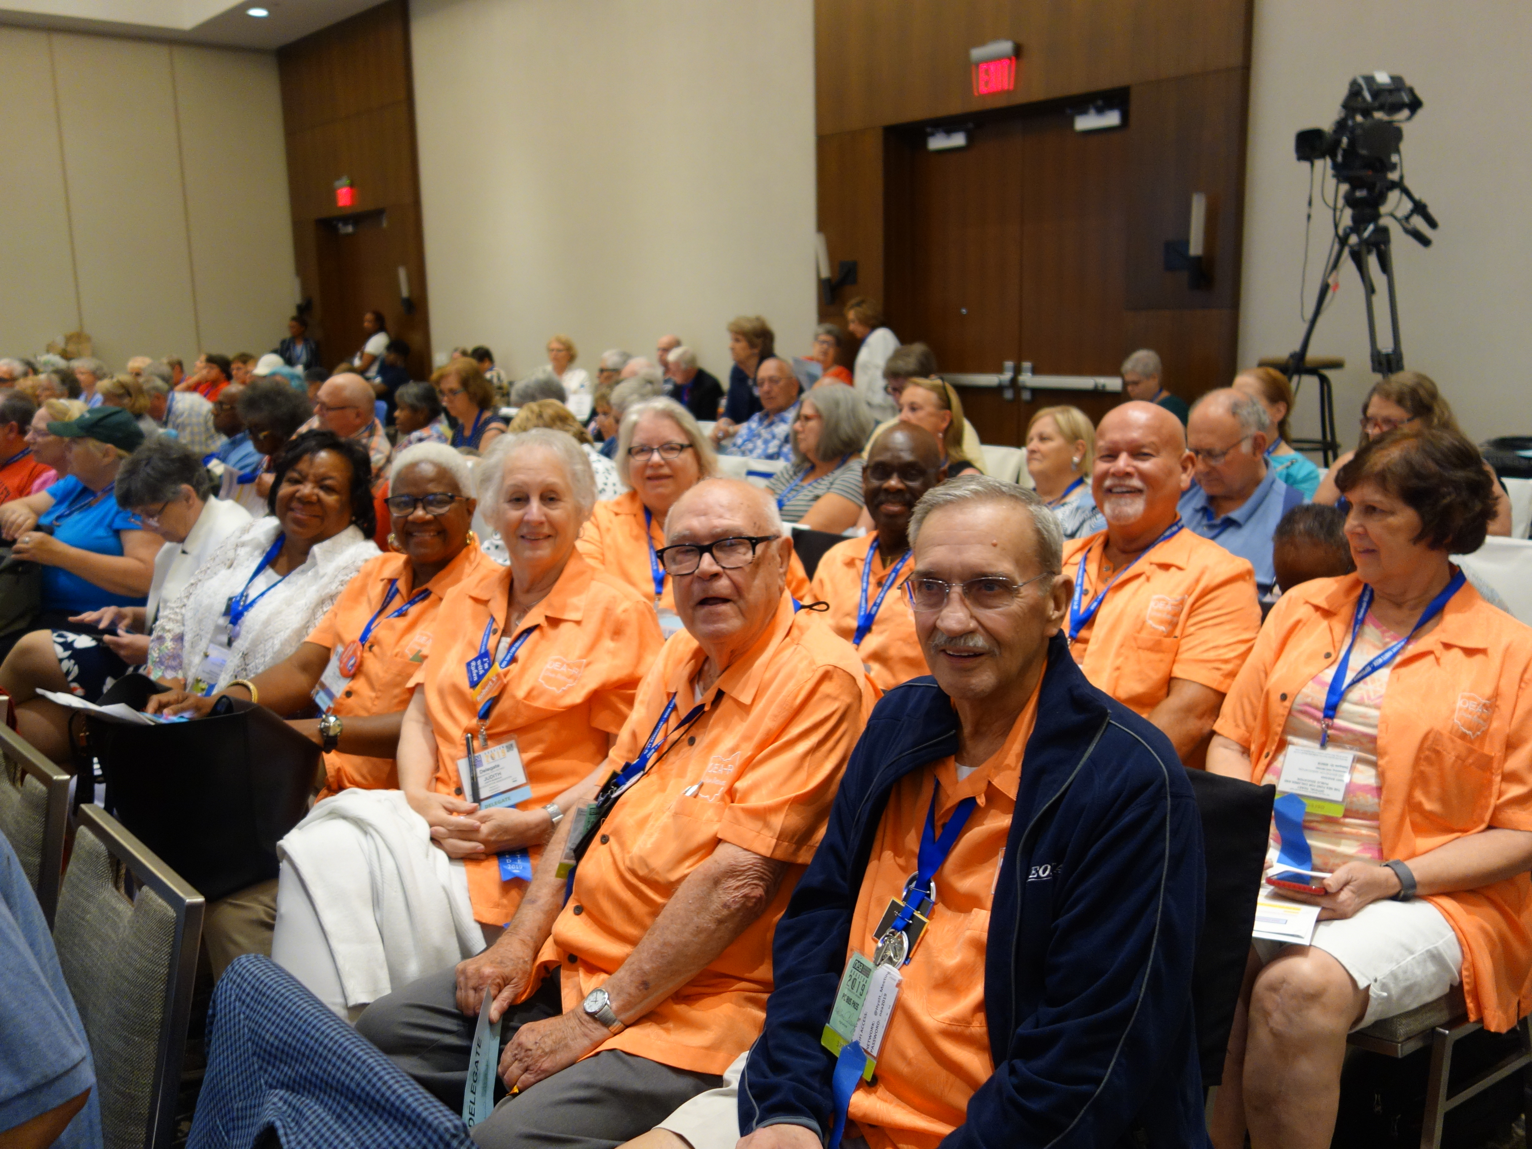

OEA-R Delegates to the 2019 NEA RA
The following item is from Sarah Borgman, President of NEA-R. Sarah is from Indiana.

Sarah Says . . .
It's not January 1 when we usually make resolutions, but maybe we need to make some new ones or at the very least, look back long enough to examine what we set out to do on our goals last fall. Let's assess, evaluate, reshuffle priorities, and take a long hard look at our accomplishments or lack thereof. What did we set out to do? What goal was foremost in our plans? What do we need to do to finish the job with quality results? Do we need more help, supplies, or determination? Maybe we need to go back to step 3 or 4 and "regroup". Remember how excited you were when you first started on your goal? What happened along the way? Are you nearly there? One Summit speaker put it this way: "Make a map showing where you are to direct where you want to go". Let's finish the job!

How many more members are waiting for you to ask them to join now and save? How many more mentoring sessions can you complete? Is there a workshop you've always wanted to have in your state or local? Let's take advantage of every opportunity to complete the good work we can do.

FALL CONFERENCE

SAVE THE DATE

September 11, 2019

OEA Building

Registration Form is on the next page!

Make checks payable to: OEA

Follow us on Face Book

